TRADE OF
Pipefitting

PHASE 2

Module 5

Technical Drawing

UNIT: 2

Standard Drawing Conventions

Produced by

In cooperation with subject matter expert:

Finbar Smith

© SOLAS 2014
Table of Contents
Unit Objective 1
Learning Outcome 2
1.0 Anatomy of an Engineering Drawing 3
1.1 Title Block 3
1.2 Co-Ordinate Grid System 4
1.3 Revision Block 5
1.4 Notes and Legends 5
2.0 Drawing Scales 7
2.1 Drawing Scales 7
2.2 Printing at the Correct Paper Size 8
2.3 Drawing Symbols 8
3.0 International Drawing Standards 10
3.1 Purpose of Drawing Standards 10
3.2 International Drawing Standards 10
Exercises 13
Additional Resources 14

Unit Objective
There are five units in Module 5. Unit 1 focuses on Drawing Methods & Types, Unit 2; Standard Drawing Conventions, Unit 3; Drawing Equipment & Practice, Unit 4; Drawings for Piping Installation, Unit 5; Traceability Record.
In this unit you will be introduced to Standard Drawing Conventions.
Module 5

Technical Drawing
Unit 1

Drawing Methods & Types
Unit 2

Standard Drawing Conventions
Unit 3

Drawing Equipment & Practice
Unit 4

Drawings for Piping Installation
Unit 5

Traceability Record

Learning Outcome
By the end of this unit each apprentice will be able to:
- Identify the following major areas of an engineering drawing:
  - Title block
  - Co-ordinate grid system
  - Revision block
  - Notes and legends
  - Engineering drawing (graphic portion)
- Explain the reasons for using scales, symbols and abbreviations on engineering drawings
- Describe why drawings must be produced to an international standards

1.0 Anatomy of an Engineering Drawing

Key Learning Points
- Identify the key parts of an engineering drawing
- Identify the purpose of the title block
- Identify the purpose of the co-ordinate grid system
- Identify the purpose of the revision block
- Identify the purpose of notes and legends on an engineering drawing
A generic engineering drawing can be divided into the following five major areas or parts
- Title block
- Co-ordinate grid system
- Revision block
- Notes and legends
- Engineering drawing (graphic portion)
The first four parts listed above provide important information about the actual drawing. The ability to understand the information contained in these areas is as important as being able to read the drawing itself. Failure to understand these areas can result in improper use or the misinterpretation of the drawing. The information contained in the fifth part or the drawing itself is covered in unit 1.

1.1 Title Block
The title block of a drawing, usually located on the bottom or lower right hand corner, contains all the information necessary to identify the drawing and to verify its validity. A title block is divided into several areas as illustrated by Figure 1 below.
The first area of the title block contains the drawing title, the drawing number, and lists the location, the site, or the vendor. The drawing title and the drawing number are used for identification and filing purposes. Usually the number is unique to the drawing and is comprised of a code that contains information about the drawing such as the site, system, and type of drawing. The drawing number may also contain information such as the sheet number, if the drawing is part of a series, or it may contain the revision level. Drawings are usually filed by their drawing number because the drawing title may be common to several prints or series of prints.
The second area of the title block contains the signatures and approval dates, which provide information as to when and by whom the component/system was designed and when and by whom the drawing was drafted and verified for final approval. This information can be invaluable in locating further data on the system/component design or operation. These names can also help in the resolution of a discrepancy between the drawing and another source of information.
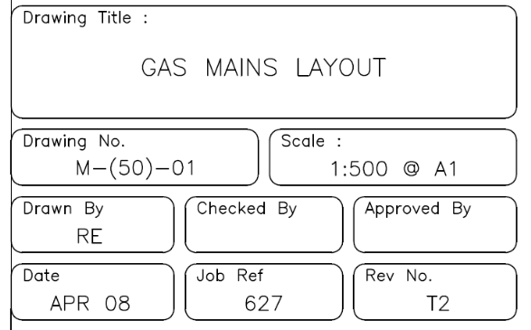
Figure 1 – Title block for engineering drawing
The third area of the title block is the reference block. The reference block lists other drawings that are related to the system/component, or it can list all the other drawings that are cross-referenced on the drawing, depending on the site's or vendor's conventions. The reference block can be extremely helpful in tracing down additional information on the system or component. Other information may also be contained in the title block and will vary from site to site and vendor to vendor. Some examples are contract numbers and drawing scale.

1.2 Co-Ordinate Grid System
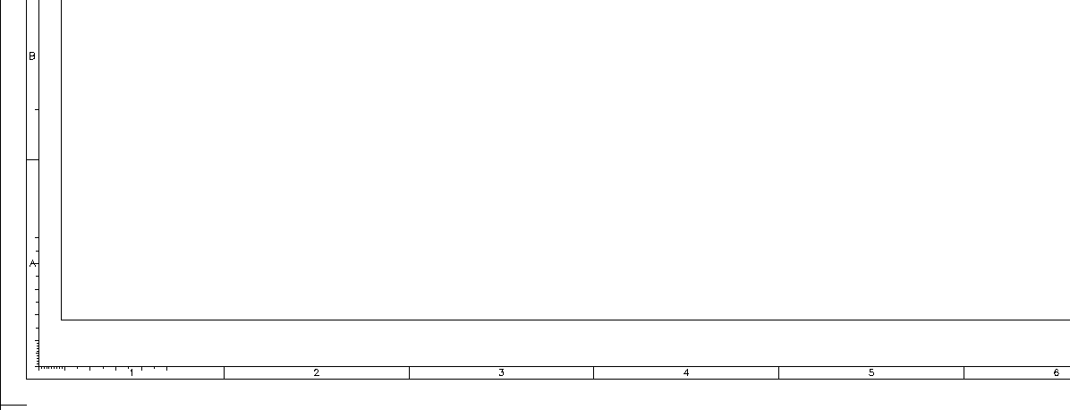
Because drawings tend to be large and complex, finding a specific point or piece of equipment on a drawing can be quite difficult. This is especially true when one wire or pipe run is continued on a second drawing. To help locate a specific point on a referenced print, most drawings, especially Piping and Instrument Drawings (P&ID) and electrical schematic drawings, have a grid system. The grid can consist of letters, numbers, or both that run horizontally and vertically around the drawing as illustrated on Figure 2. Like a city map, the drawing is divided into smaller blocks, each having a unique two letter or number identifier. For example, when a pipe is continued from one drawing to another, not only is the second drawing referenced on the first drawing, but so are the grid coordinates locating the continued pipe. Therefore the search for the pipe contained in the block is much easier than searching the whole drawing.
Figure 2 – Co-ordinate grid system for engineering drawing

1.3 Revision Block
As changes to a component or system are made, the drawings depicting the component or system must be redrafted and reissued. When a drawing is first issued, it is called revision zero, and the revision block is empty. As each revision is made to the drawing, an entry is placed in the revision block. This entry will provide the revision number, a title or summary of the revision, and the date of the revision. The revision number may also appear at the end of the drawing number or in its own separate block, as shown in Figure 2, Figure 3. As the component or system is modified, and the drawing is updated to reflect the changes, the revision number is increased by one, and the revision number in the revision block is changed to indicate the new revision number. For example, if a Revision 2 drawing is modified, the new drawing showing the latest modifications will have the same drawing number, but its revision level will be increased to 3. The old Revision 2 drawing will be filed and maintained in the filing system for historical purposes.
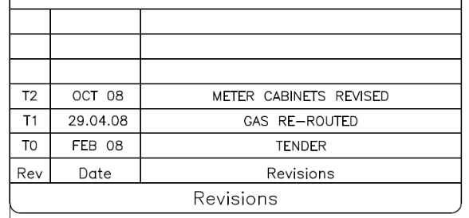
Figure 3 – Revision block for engineering drawing
There are two common methods of indicating where a revision has changed a drawing that contains a system diagram. The first is the cloud method, where each change is enclosed by a hand-drawn cloud shape, as shown in Figure 4. The second method involves placing a circle (or triangle or other shape) with the revision number next to each effected portion of the drawing, as shown in Figure 4. The cloud method indicates changes from the most recent revision only, whereas the second method indicates all revisions to the drawing because all of the previous revision circles remain on the drawing.
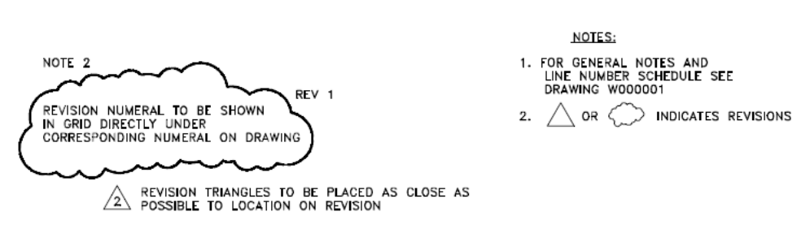
Figure 4 – Methods for noting drawing changes

1.4 Notes and Legends
Drawings are comprised of symbols and lines that represent components or systems. Although a majority of the symbols and lines are self-explanatory or standard, a few unique symbols and conventions must be explained for each drawing. The notes and legends section of a drawing lists and explains any special symbols and conventions used on the drawing, as illustrated in Figure 5. Also listed in the notes section is any information the designer or draftsman felt was necessary to correctly use or understand the drawing. Because of the importance of understanding all of the symbols and conventions used on a drawing, the notes and legend section must be reviewed before reading a drawing.
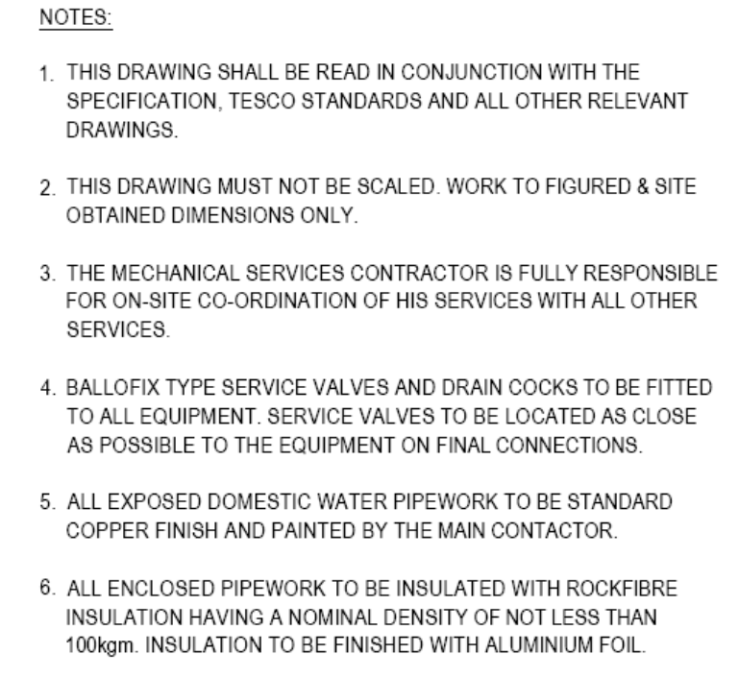
Figure 5 – Typical notes on an engineering drawing

2.0 Drawing Scales

Key Learning Points
- Identify the purpose of scales on drawings
- Identify how different scales are used to enlarge or reduce actual components or piping systems
- Identify why scale drawings must be printed on the correct size paper
- Identify why drawing symbols are used
- Identify why drawings are produced to international drawing standards

2.1 Drawing Scales
All drawings can be classified as either drawings with scale or those not drawn to scale. Drawings without a scale usually are intended to present only functional information about the component or system. Prints drawn to scale allow the figures to be rendered accurately and precisely. Scale drawings also allow components and systems that are too large to be drawn full size to be drawn in a more convenient and easy to read size. The opposite is also true. A very small component can be scaled up, or enlarged, so that its details can be seen when drawn on paper. Scale drawings usually present the information used to fabricate or construct a component or system. If a drawing is drawn to scale, it can be used to obtain information such as physical dimensions, tolerances, and materials that allows the fabrication or construction of the component or system. Every dimension of a component or system does not have to be stated in writing on the drawing because the user can actually measure the distance (e.g., the length of a part) from the drawing and divide or multiply by the stated scale to obtain the correct measurements.
The scale of a drawing is usually presented as a ratio and is read as illustrated in the following examples.
- 1:1 Read as 1 unit usually millimeters (on the drawing) equals 1 unit (on the actual component or system). This can also be stated as FULL SIZE in the scale block of the drawing. The measured distance on the drawing is the actual distance or size of the component.
- 5:1 Read as 5 units (on the drawing) equals 1 unit (on the actual component or system). This is an enlarging scale. For example, if a component part measures 10mm on the drawing the actual component measures 2mm. This type of scale would be used a lot for small intricate machined components.
- 1:100 Read as 1 unit (on the drawing) equals 100 units (on the actual component or system). This is reducing scale. For example, if a length of pipe measures 10mm on the drawing the actual length of pipe measures 1 meter. This type of scale would be used for building layouts and bigger scales such as 1:250 and 1:500 would be used for site layouts.

2.2 Printing at the Correct Paper Size
In the days before computers, CAD packages and printers all drawings were drawn by hand on fixed size paper and it was sufficient to write the actual scale (1:100, 1:250) in the title block. However as most drawings are now drawn on computers and can be printed anywhere in the world it is necessary to write the scale and the page size at which the drawing is printed on e.g. 1:100 @ A1 paper size. If this drawing is printed on any other size paper then the scale is no longer accurate.

2.3 Drawing Symbols
To read and interpret piping and instrument drawings (P&IDs) and general arrangement (GAs), the reader must learn the meaning of the symbols. Figure 6 illustrates a range of typical symbols used for piping process and instrumentation drawings. It is important to note that this is only a representative sample of fluid system symbols, rather than being all-inclusive. The symbols presented herein are commonly used in engineering P&IDs. The pipe fitter must expand his or her knowledge by obtaining and studying the appropriate master symbols drawing that is relevant to the facility where they are working.
It should also be noted that some components such as globe and gate valves can often be depicted by the same valve symbol or different types of pumps depicted by a common pump symbol. In such cases, information concerning the valve or pump type may be conveyed by the component identification number or by the notes and legend section of the drawing; however, in many instances even that may not hold true. When the understanding of common symbols is mastered, the reader should be able to interpret most P&IDs.
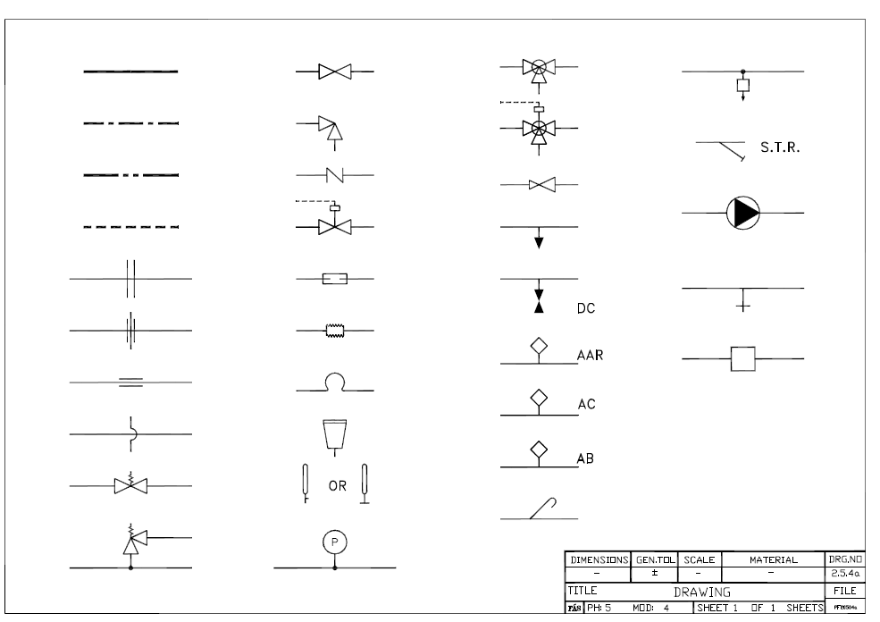
Figure 6 – Typical symbols used on and engineering P&ID drawing
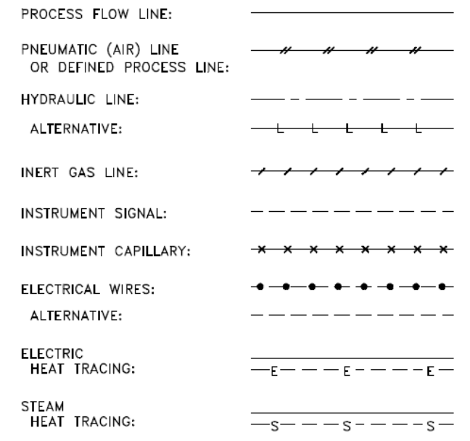
P&ID drawings for a particular process system may indicate other systems or services that interact with the main system on the drawing. To illustrate different services, the draughtsperson may use different line types as illustrated in Figure 7 below. Example, although the main process flow line may carry water, the associated auxiliary piping may carry compressed air, inert gas, or trace heating service. Also, a P&ID may also depict instrument signals and electrical wires as well as piping.
Figure 7 – Differentiation of services by different line types

3.0 International Drawing Standards

Key Learning Points
- Identify why international drawing standards are used
- Identify the key international drawing standards

3.1 Purpose of Drawing Standards
Engineering drawing is a formal and precise way of communicating information about the shape, size, features and precision of physical objects. Drawing is the universal language of engineering and drawing standards ensure that there is consistency between the draughts persons producing the drawings and the pipefitters who are reading them in the field. Drawing standards are used to control the following aspects of drawings:
- Terms and definitions
- Types of documentation
- Scales, units and quantities
- Lines, arrows and terminators; lettering
- Projections and views; sections
- Symbols and abbreviations
- Representation of features and components
- Dimensioning and tolerancing; geometrical tolerancing
- Surface texture indication
- Graphical representation and annotation for 3-D modeling output)

3.2 International Drawing Standards
As with piping standards there are many different standards for drawings, some of the more common ones are as follows:
- British standards BS 8888:2006 Specification for defining, specifying and graphically representing products.
- The ISO Drawing standard of which Part 1 covers technical drawings in general including:
  - ISO 128-20:1996 Technical drawings — General principles of presentation — Part 20: Basic conventions for lines
  - ISO 128-21:1997 Technical drawings — General principles of presentation — Part 21: Preparation of lines by CAD systems
  - ISO 128-22:1999 Technical drawings — General principles of presentation — Part 22: Basic conventions and applications for leader lines and reference lines
  - ISO 128-23:1999 Technical drawings — General principles of presentation — Part 23: Lines on construction drawings
  - ISO 128-24:1999 Technical drawings — General principles of presentation — Part 24: Lines on mechanical engineering drawings
  - ISO 128-25:1999 Technical drawings — General principles of presentation — Part 25: Lines on shipbuilding drawings
  - ISO 128-30:2001 Technical drawings — General principles of presentation — Part 30: Basic conventions for views
  - ISO 128-34:2001 Technical drawings — General principles of presentation — Part 34: Views on mechanical engineering drawings
  - ISO 128-40:2001 Technical drawings — General principles of presentation — Part 40: Basic conventions for cuts and sections
  - ISO 128-44:2001 Technical drawings — General principles of presentation — Part 44: Sections on mechanical engineering drawings
  - ISO 128-50:2001 Technical drawings — General principles of presentation — Part 50: Basic conventions for representing areas on cuts and sections
  - ISO 129:1985 Technical drawings — Dimensioning — General principles, definitions, methods of execution and special indications
  - ISO 406:1987 Technical drawings — Tolerancing of linear and angular dimensions
  - ISO 2553:1992 Welded, brazed and soldered joints — Symbolic representation on drawings
- ASME drawing standards including
  - ASME Y14.1- Imperial drawing sheet size and format
  - ASME Y14.1M- Metric drawing sheet size and format
  - ASME Y14.100- Engineering drawing and practices
  - ASME Y14.2- Line conventions and lettering
  - ASME Y14.3- Multi-view and sectional view drawings
  - ASME Y14.4- Pictorial drawings
  - ASME Y14.5- Dimensioning and Tolerancing
  - ASME Y14.24- Types and applications of Engineering drawings
  - ASME Y14.34- Associated lists
  - ASME Y14.35- Drawing revisions
  - ASME Y14.38- Abbreviations
  - ASME Y14.41- Digital product definition drawing practices
  - ASME Y14.42- Electronic approval systems
While it is not a requirement to be familiar with every drawing standard, it is important to be aware that the different standards exist. If completing a drawing, standards should not be mixed, the drawing should consistently use one family of standards, i.e. the BS standard only.

Exercises
- Complete Work Permit form as per Exercise No.2.4.1

Additional Resources

Title | Author | Ref. Code
The Induction Book, “Code of Behaviour & Health & Safety Guidelines” | SOLAS
Basic Welding and Fabrication | W Kenyon | ISBN 0-582-00536-L
Fundamentals of Fabrication and Welding Engineering | FJM Smith | ISBN 0-582-09799-1
Workshop processes, practices and materials, 3rd edition, Elsevier Science & Technology | Black, Bruce J 2004 | ISBN-13: 9780750660730
New Engineering Technology | Lawrence Smyth & Liam Hennessy | ISBN 086 1674480

Videos:
- Understanding welding fumes
- Welder on Site…Be Aware (Vocam)
- Powered hand tool safety (Vocam)
- Industrial Ergonomics (Vocam)
Available from:
Vocam Ireland
Circle Organisation Ltd
Friar Street, Thurles, Co Tipperary, Ireland
Tel: +353 504 24666

Castleforbes House
Castleforbes Road
Dublin 1

